CHEMISTRY FOR ENGINEERING

ASSIGNMENT 1 SOLUTION

**PART I: MULTIPLE CHOICE QUESTIONS: (15 questions, 1 point each)**

1. d. The correct symbol for B is Boron.

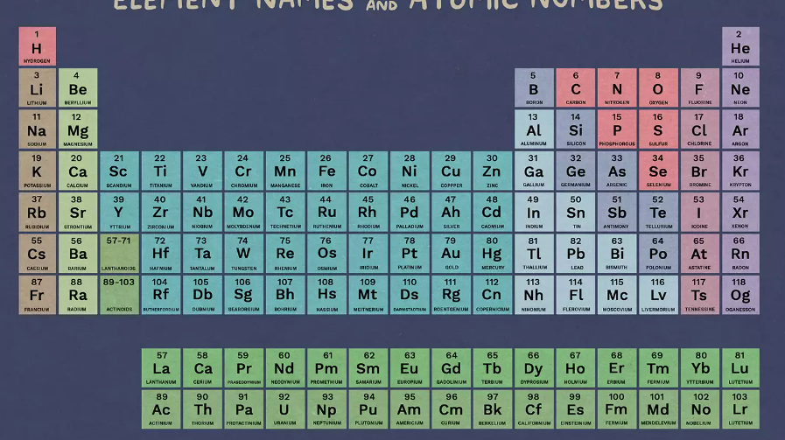

1. b. You should recognized ml is equal cm3.
2. c. . Similar for Fe and Cr.
3. c. For equation contain sum and minus, the result significant figure take the lowest significant figure after the coma, in this case is 2 significant.
$$1.314 + 189.71=191.00$$

4. b. We don’t need explain for this right. ☺

1. a. The significant figure count from left to right and start after meet first number different from zero. But all the zero after start are counted.
2. 0.04309
3. 0.0430
4. 0.043090
5. 0.043980
6. a.
7. a.

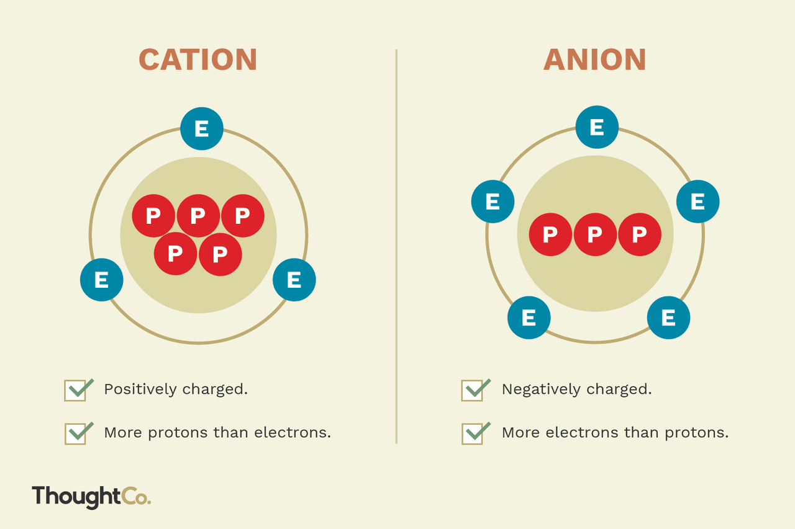

1. d. protons and neutrons has approximately same mass while electron have way smaller mass compare to these two.

**Protons and neutrons** have approximately the same mass, but they are both much more massive than electrons

1. c.
2. a. For predict the atomic mass for this atom, we find sum of the product for each mass peak mass with its relative atomic abundant.
$$M=\frac{25×1+26×4}{5}=25.8 (g/mol)$$

3. a.
$$Numer of neutrons=Z (mass number) - A (Atomic number) =226-88=136$$

4. c. Kr has atomic number 36, so for [Kr]5s24d2, we only need to find the atom with atomic number of 36 + 4 = 40, and that is Zirconium.

**[He] = 2, [Ne] = 10, [Ar] = 18, [Kr] = 36, [Xe] = 54, or [Rn] = 86**

1. a. number of atom and electron are equal to atomic number of Cu which is 29. Neutrons number are calculate as question 12 above.
2. c. The trending of ionization energy in periodic table is increase from bottom to the top and from left to right. (With the increase of period, the atom increase in electrons layer, lead to the distance between nucleus and electron at outer layer is increase while decreases in the attractive between it, this result in decrease for first ionize energy. With the increase in atomic number from left to right, although there no changing in number of layer for atom in same period, but the increase in atomic number lead to increase in positive charge in nucleus, result in increase of its attraction force with outer layer electrons as well as it first electron ionize energy.)

**PART II: CONSTRCUTED QUESTION: (55 points)**

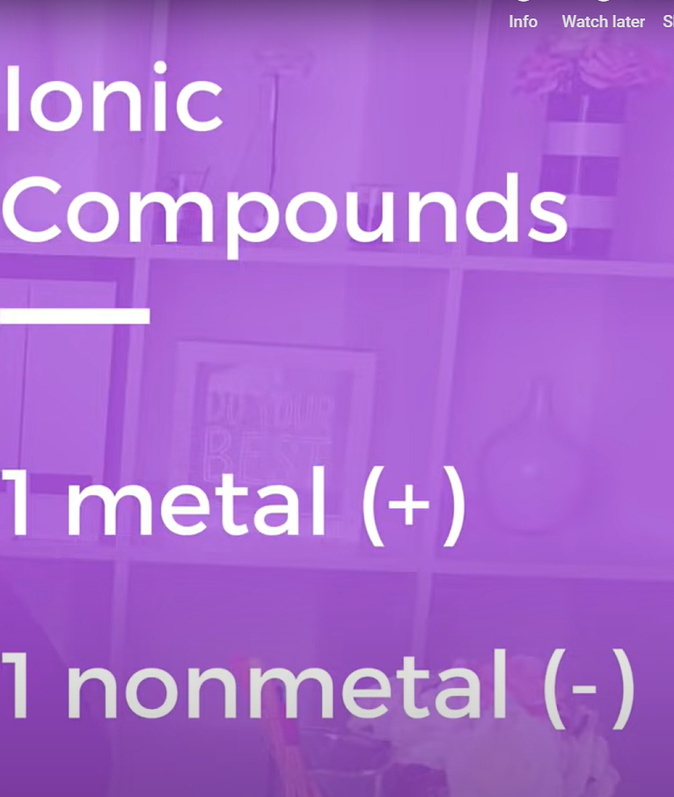

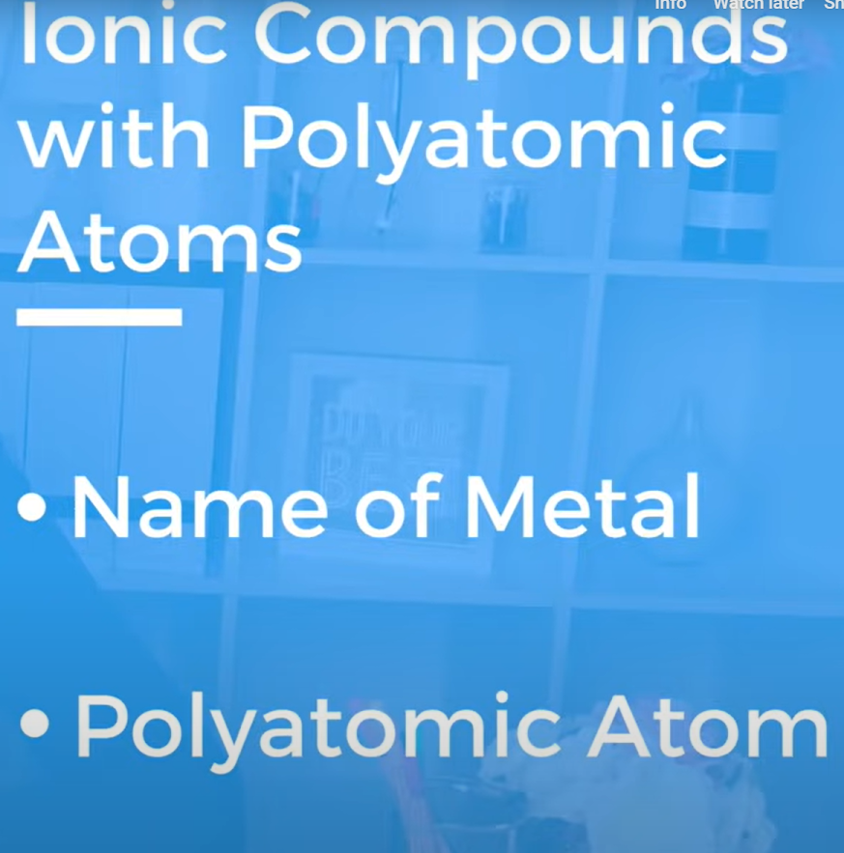

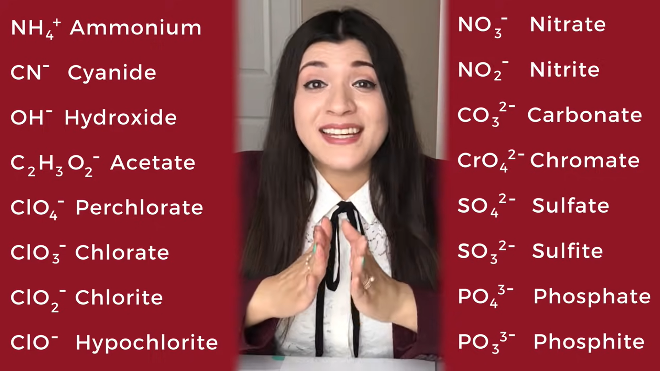



|  |  |  |
| --- | --- | --- |
| **NAME** | **COMPOUND** | **How many atoms are in one “formula unit”?** |
| Sulfuric acid | H2SO4 (aqueous) | 7 |
| Manganese (VII) oxide | Mn2O7 | 9 |
| Ferric hydroxide  (Iron (III) hydroxide) | Fe(OH)3 | 4 |
| Copper (II) chloride  hexahydrate | CuCl2.6H2O | 21 |
| Hydrogen chloride | HCl (gas) | 2 |
| Nickel (IV) Chloride | NiCl4 | 5 |
| Hydrobromic acid | HBr (aqueous) | 2 |
| Sodium carbonate decahydrate | Na2CO3.10H2O | 36 |
| Lithium nitrite | LiNO2 | 4 |
| Potassium cyanide | KCN | 3 |



1. Neutrons have similar mass to protons and way higher mass of electrons. Therefore, when we talk about atomic mass, we can approximate it as sum of protons and neutrons in atom.
2. Compare to atom, the size of nucleus is very small. However, it contain most weight of the atom.
3. Atoms of the same element that have different masses are called isotope.

|  |  |  |  |  |  |
| --- | --- | --- | --- | --- | --- |
| **Symbol** | **Number of protons** | **Number of electrons** | **Number of neutron** | **Atomic number** | **Mass number** |
| 34S2- | 16 | 18 | 18 | 16 | 34 |
| 1H | 1 | 1 | 0 | 1 | 1 |
| 181Ta | 73 | 73 | 108 | 73 | 181 |
| 8O2- | 8 | 10 | 9 | 8 | 17 |
| 238U4+ | 92 | 88 | 146 | 92 | 238 |

**PROTONS = ATOMIC NUMBER**

**NEUTRONS = MASS – ATOMIC NUMBER**

**ELECTRON = ATOMIC NUMBER – CHARGE**



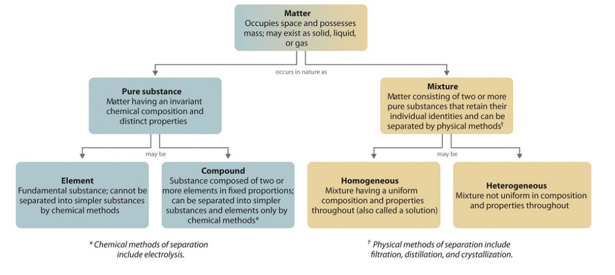

3. This case have no new substance are form so this is **physical change.**
4. This case only involve phase change and no new substance are form so this is **physical change.**
5. In this case, some ingredient in milk are react and turn into other subtnace so it is **chemical change**.

At 25°C, chlorine is a green-yellow gas with a density of 3 × 10–3 g/cm3. Chlorine has a melting point of –101°C and a boiling point of –35°C, and the energy required to melt and boil chlorine is 6.4 and 20.4 kJ/mol, respectively. Chlorine burns in hydrogen to form hydrogen chloride.

2. Ti2+: [Ar] 3d2
3. O: [He] 2s2 2p4
4. Br -: [Ar] 3d10 4s2 4p6
5. Fe: [Ar] 3d6 4s2
6. Cr3+: [Ar] 3d3

**[He] = 2, [Ne] = 10, [Ar] = 18, [Kr] = 36, [Xe] = 54, or [Rn] = 86**

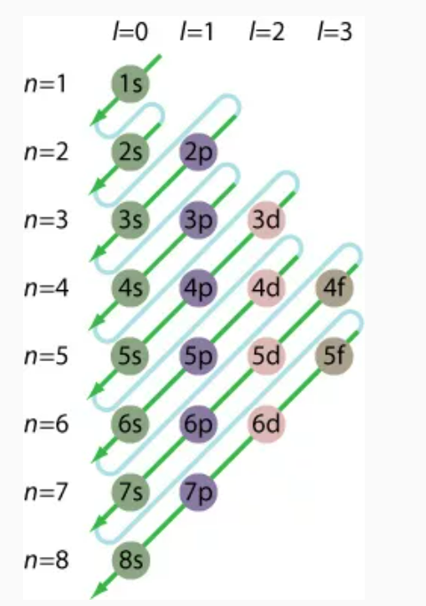



1. As, N, F
2. F, C, Si
3. Si, C, F
4. Ga, Ge, Si, S
5. P, O, F

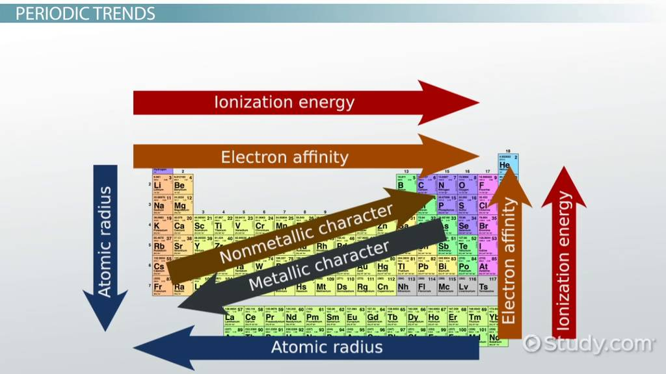

**PART III: IDENTIFICATION AND CORRECTION FALSE STATEMENTS**

**(30 points)**a. False. X is Zn

The **metal X** is **zinc, Zn**

**Explanation:**

**Given:**

Salt with formula .

The **X-ion** has **28 electrons**

**To find:**

The **metal X**

**Solution:**

In the salt , there are **two halogen atoms** which means that **must have borrowed**the **one-electron** each from the **central atom X.**

Number of **electrons**in **X-ion** = 28

So, the **total number of electrons** in the**atom of X**will be:

28 + 2 = 30

And as we know that **atom**is**electrically neutral** that an **equal number**of **electrons**and **protons**are present in it.

Number of **protons**= Number of **electron**= 30

Number of **protons i**n**X atom** = 30

**Atomic number**of **X** =Number of **protons = 30**

The**atomic number**of**Ni, Zn, Fe, and V** are**28, 30, 26, and 23 respectively.**

So, from this, we can conclude that the **metal X** is **zinc, Zn.**

**Learn more about atoms here:**

[brainly.com/question/20108206](https://brainly.com/question/20108206)

[brainly.com/question/1527888?referrer=searchResults](https://brainly.com/question/1527888?referrer=searchResults)

b. True.



c. False. Name of compound NH4Cl (g) is ammonium chloride.

d. True.

e. True.

f. False. In group VA.

g. False. [Ar] 3d10 4s2 4p4

h. True.

i. True.

j. False. Heterogeneous mixture since the bubbles is solid phase in milk tea is liquid phase.

k. True. artificial resins Nhựa tổng hợp

l. True

m. False. [Ar] 3d4 4s2

n. False. Protons

o. True.

p. True.

q. True

r. True

s. False atomic number

t. True

u. True